EXP.NO: 1
Web Page Creation using HTML

AIM:
To create a web page for an Online Result Collector Management System that embeds a college map with hotspots, frames, and links. The web page is designed using HTML with embedded, external, and inline CSS for styling. This experiment improves understanding of frames, navigation links, hotspot image maps, Google Maps embedding, and CSS styling methods

ALGORITHM:
- Create the HTML Structure:
Set up the basic HTML document using <!DOCTYPE html>, <html>, <head>, and <body> tags.
In the main file index1.html, use the <frameset> tag to divide the page into three sections:
- Header frame
- Menu frame
- Content frame
Load header1.html, menu1.html, and home1.html into the respective frames.
2) Create CSS Styles:
- External
Create a separate file style1.css and define common styles such as body background color, font family, container padding, card box design, and shadow effects..
- Inline
Apply inline styling directly to headings, buttons, text boxes, table borders, and image alignment..
- Embedded
Use the <style> tag inside header1.html, menu1.html, home1.html, and contact1.html for page-specific design..
3) Menu Navigation:
Create menu1.html with navigation links using the <a> tag.
The menu should contain:
- HOME
- RESULTS
- SEARCH
- COLLEGE MAP
.
4) Header Page:
Create header1.html to display the title:
ONLINE RESULT COLLECTOR MANAGEMENT SYSTEM
5) Home Page with Hotspot:
- Create home1.html as the welcome page.
- Display a large centered college image using the <img> tag.
- Use the <map> and <area> tags to create a clickable hotspot on the image.
- When the hotspot is clicked, it should open results1.html.
6) Result Page:
Create results1.html to display student results in table format.
7) Search Page:
Create search1.html with form input for register number search.
8) College Map Page:
Create contact1.html to display the college location using Google Maps iframe.
9) Test the Web Page:
Run index1.html and verify all pages.
10) Verify Final Output:
Ensure frames, links, hotspot, map, and CSS work correctly
CODE:
Index1.html:
<!DOCTYPE html>
<html>
<head>
<title>Online Result Collector</title>
</head>

<frameset rows="100,60,*">
<frame src="header1.html" name="headerFrame" noresize>
<frame src="menu1.html" name="menuFrame" noresize scrolling="no">
<frame src="home1.html" name="contentFrame">
</frameset>
</html>
Style1.css :
body{
margin:0;
font-family:Arial, sans-serif;
background:#f5f5f5;
}

.container{
padding:30px;
}

.card{
background:white;
padding:20px;
border-radius:10px;
box-shadow:0 0 10px rgba(0,0,0,0.1);
}

Header1.html :
<!DOCTYPE html>
<html>
<head>
<style>
body{
margin:0;
background:#003366;
color:white;
text-align:center;
font-family:Arial;
padding:25px;
}
</style>
</head>
<body>
<h1>ONLINE RESULT COLLECTOR MANAGEMENT SYSTEM</h1>
</body>
</html>
Menu1.html :
<!DOCTYPE html>
<html>
<head>
<style>
body{
margin:0;
font-family:Arial;
}

.menu{
display:flex;
justify-content:center;
background:#222;
}

.menu a{
color:white;
padding:15px 30px;
text-decoration:none;
font-weight:bold;
}

.menu a:hover{
background:#444;
}
</style>
</head>
<body>

<div class="menu">
<a href="home1.html" target="contentFrame">HOME</a>
<a href="results1.html" target="contentFrame">RESULTS</a>
<a href="search1.html" target="contentFrame">SEARCH</a>
<a href="contact1.html" target="contentFrame">COLLEGE MAP</a>
</div>

</body>
</html>
Home1.html :
<!DOCTYPE html>
<html>
<head>
<link rel="stylesheet" href="style1.css">
<style>
.image-box{
text-align:center;
margin-top:30px;
}

.image-box img{
width:800px;
height:450px;
object-fit:cover;
border-radius:10px;
}
</style>
</head>
<body>

<div class="container">
<div class="card">
<h2 style="color:#003366; text-align:center;">Welcome</h2>
<p style="text-align:center;">
Welcome to the Online Result Collector Management System.
Students can view semester results and search marks easily.
</p>

<div class="image-box">
<img src="college1.jpg" usemap="#deptmap">
</div>

<map name="deptmap">
<area shape="rect" coords="100,100,300,250" href="results1.html" target="contentFrame">
</map>
</div>
</div>

</body>
</html>
Results1.html :
<!DOCTYPE html>
<html>
<head>
<link rel="stylesheet" href="style1.css">
</head>
<body>

<div class="container">
<div class="card">
<h2>Student Results</h2>
<table border="1" cellpadding="10" width="100%">
<tr>
<th>Register No</th>
<th>Name</th>
<th>Subject</th>
<th>Mark</th>
</tr>
<tr>
<td>101</td>
<td>Suria</td>
<td>Web Technology</td>
<td>95</td>
</tr>
<tr>
<td>102</td>
<td>Arun</td>
<td>DBMS</td>
<td>89</td>
</tr>
</table>
</div>
</div>

</body>
</html>

Search1.html
<!DOCTYPE html>
<html>
<head>
<link rel="stylesheet" href="style1.css">
</head>
<body>

<div class="container">
<div class="card">
<h2>Search Student Result</h2>

<form>
Register No:
<input type="text" style="padding:8px; width:200px;">
<input type="submit" value="Search" style="padding:8px; background:green; color:white;">
</form>
</div>
</div>

</body>
</html>
Contact1.html
<!DOCTYPE html>
<html>
<head>
<title>College Location</title>
<style>
body{
margin:0;
font-family:Arial;
background:#f5f5f5;
}

.container{
text-align:center;
padding:30px;
}

iframe{
border:3px solid #003366;
border-radius:10px;
}
</style>
</head>
<body>

<div class="container">
<h2>College Map Location</h2>

<iframe
src="https://www.google.com/maps/embed?pb=!1m18..."
width="800"
height="450"
style="border:0;">
</iframe>

<p>XYZ Engineering College, Chennai</p>
</div>

</body>
</html>

OUTPUT:
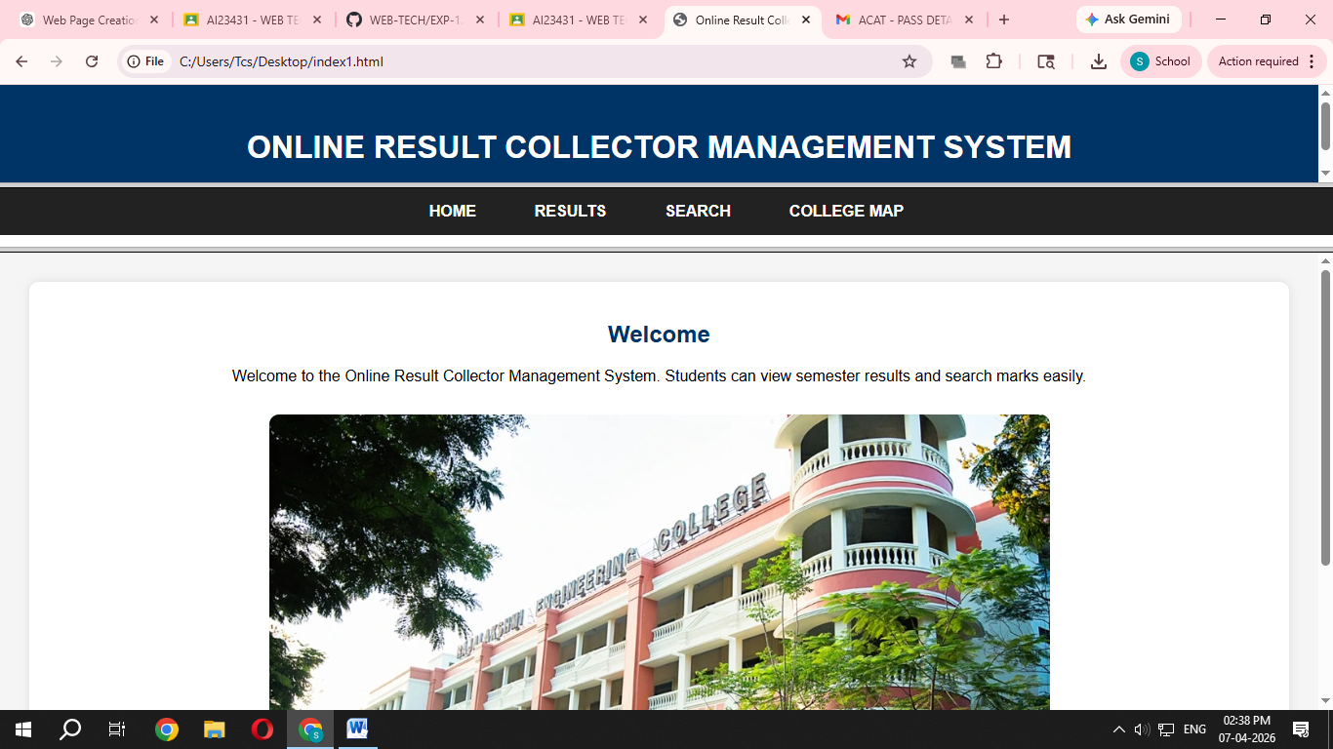

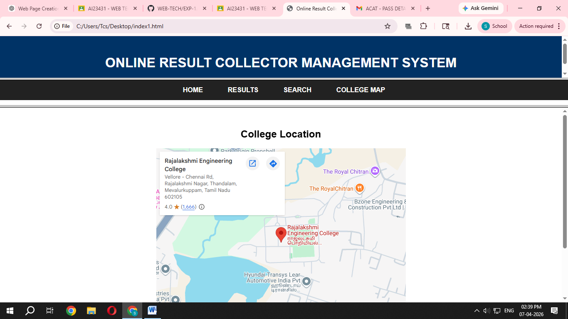
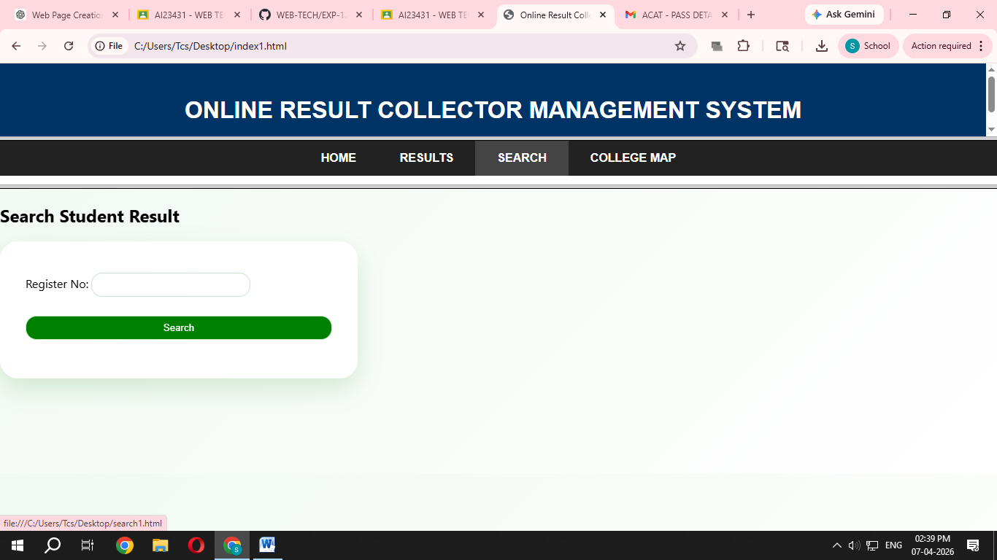

Result:
Thus the HTML web page for Online Result Collector Management System with college map, hotspot, frames, links, embedded CSS, external CSS, and inline CSS was created successfully.

